CS5590VC Lab3

Jian Wang

09/10/2013

Part1

In this Mashup application I consume two web service APIs:

1. Google search API can be used to customize and search any items you like.

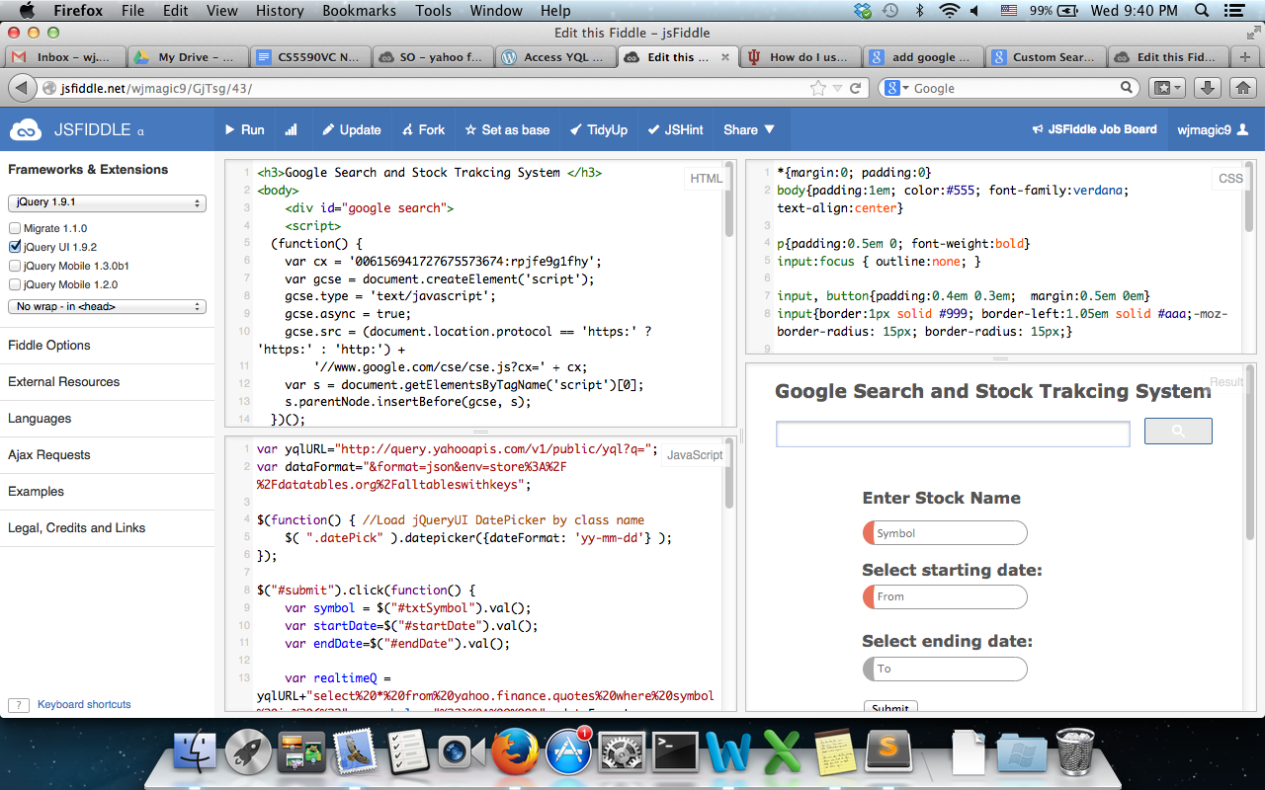

Once input name (eg. Yahoo) and click search, a window containing results will be popped out.

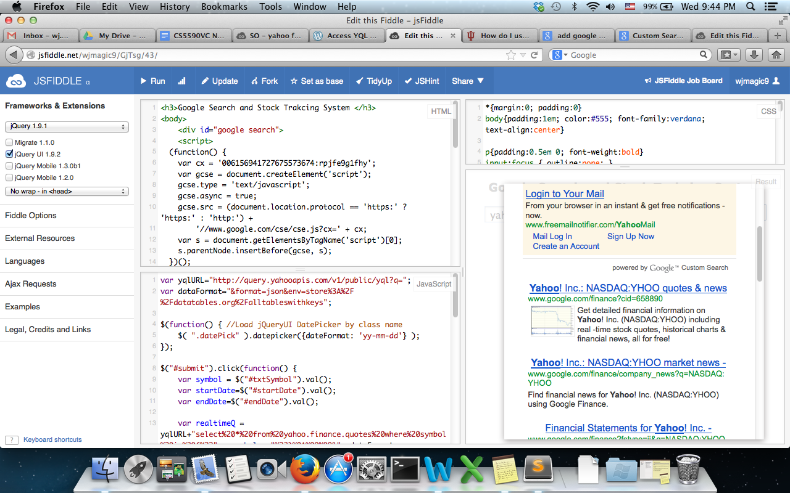

2. Yahoo finance API can be used to build real-time stock tracking system. In this example, I can input stock’s name, starting date and ending date. The results including stock’s name, current real time bid, Today average volume, Today price change, and all the history price between these periods(eg 09/02/2013 to 09/11/2013) will be shown up.

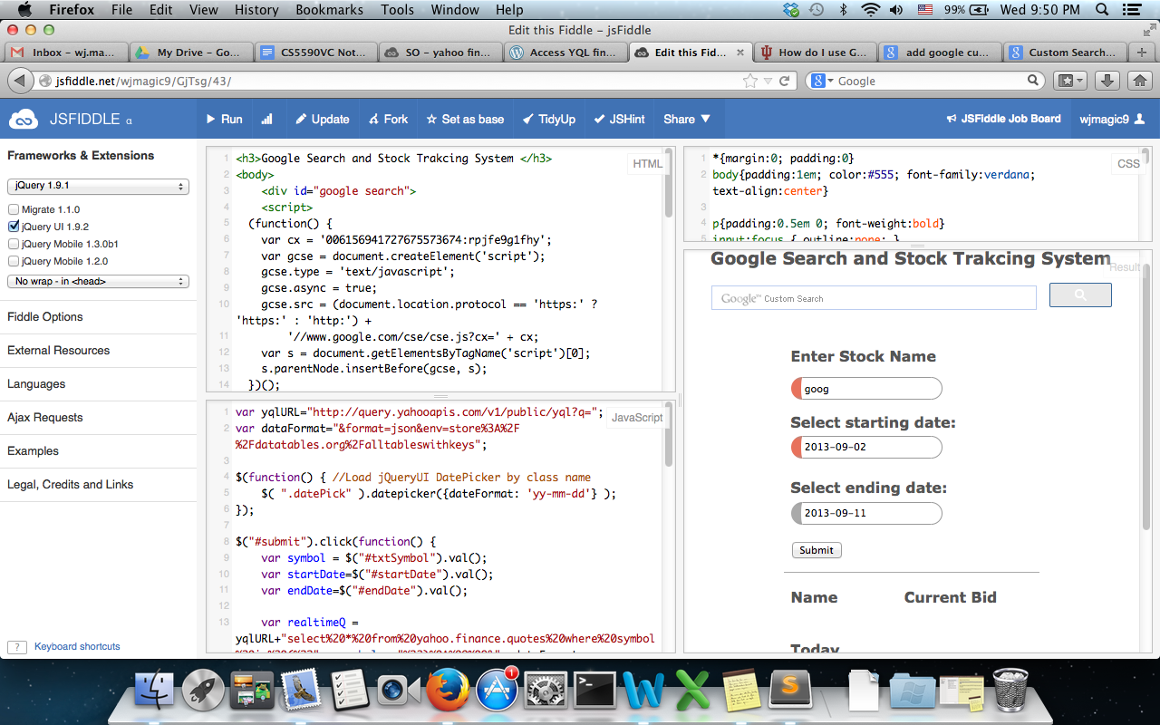

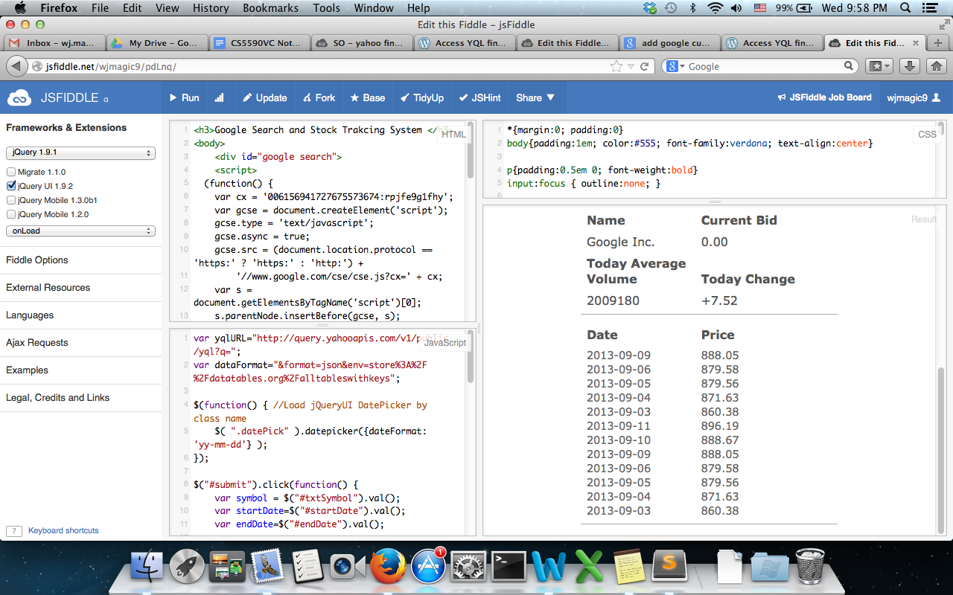

Part2

1. After install Glassfish through eclipse, created a project name 5590VC_test2

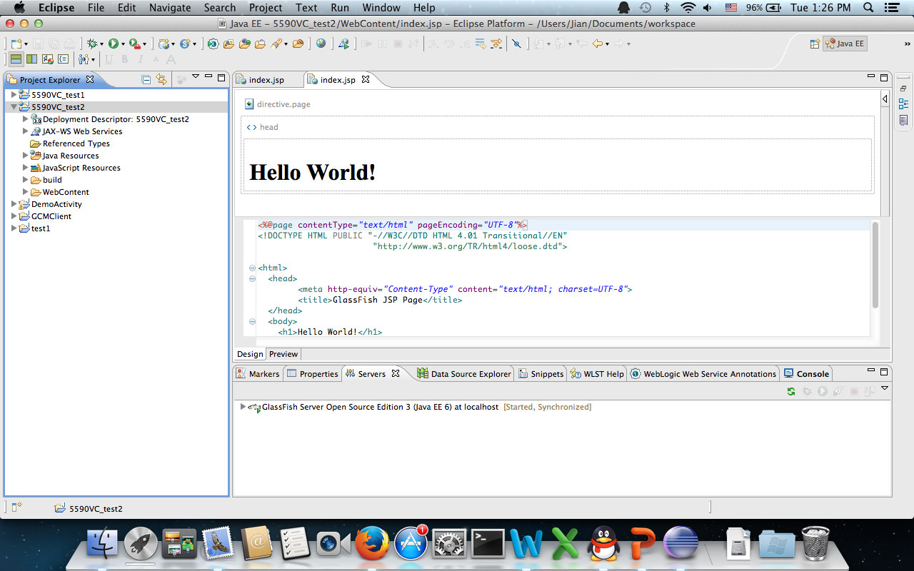

1. Creating REST Web Service, file name: restservice.java

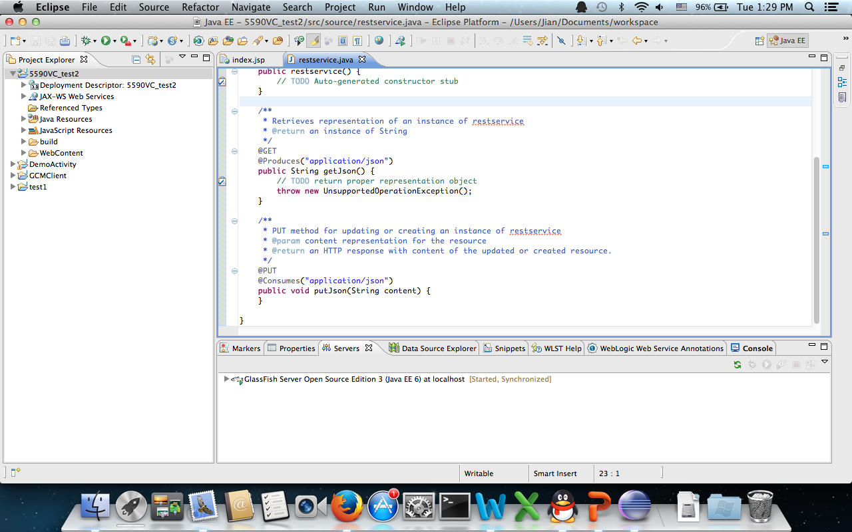

1. Do the testing on url, adding name, generate specific contents:

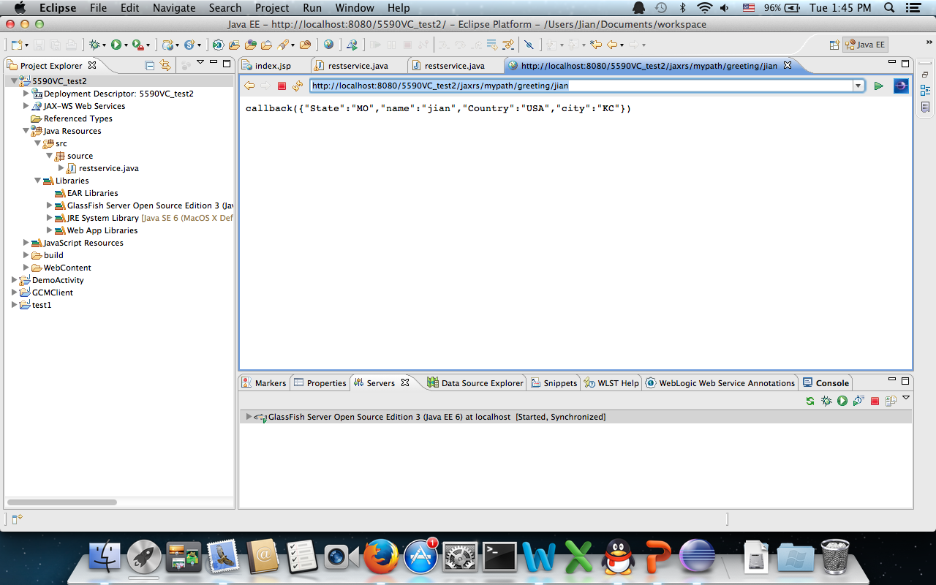

1. Then download Glassfish3 from internet and copy it to Linux remote instance, deploy it.

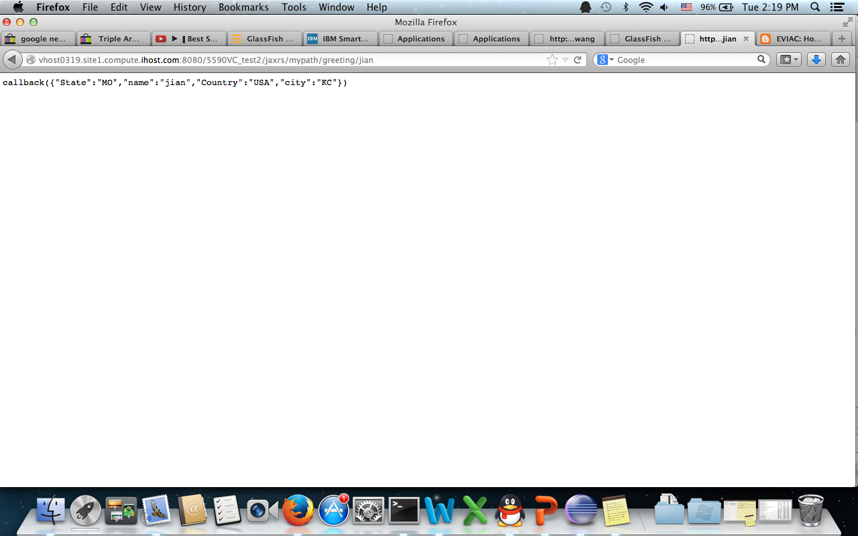

1. Access this RESTful service through Javascript

